Marijuana Moment

Senate Committee Pushes VA To Consider Medical Marijuana As Opioid Alternative For Military Veterans

Published

on
July 15, 2024
By
Kyle Jaeger
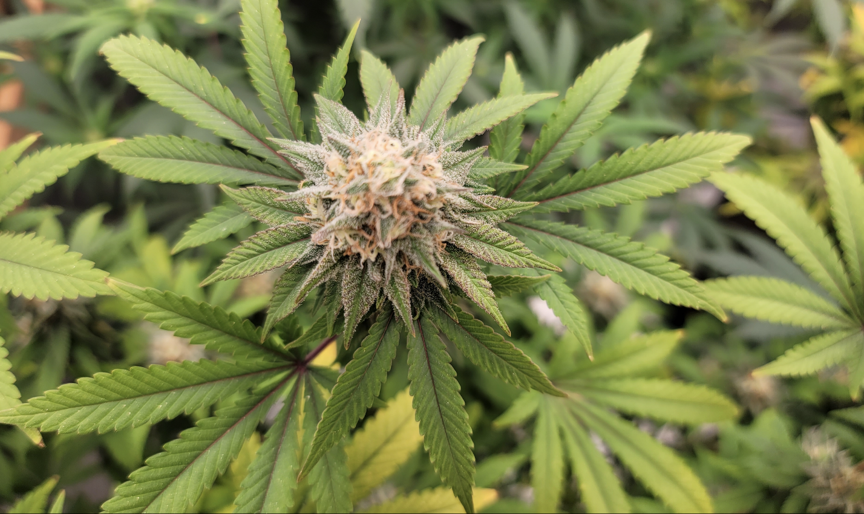
A Senate committee is urging the U.S. Department of Veterans Affairs (VA) to explore medical marijuana as an alternative to opioids for veterans, and it’s also asking the agency to consider allowing its doctors to formally recommend cannabis to their patients in light of the Biden administration’s rescheduling push.
In a series of reports attached to spending bills that moved through the Senate Appropriations Committee on Thursday, lawmakers included a variety of marijuana, psychedelics and hemp sections—including a directive for VA to account for a little-known policy that blocks veterans from receiving GI benefits for educational courses aimed at preparing them to participate in the cannabis industry.
The appropriations legislation was approved by the Senate panel just days after a GOP-led House committee passed its versions, with reports that include sections critical of the marijuana rescheduling move and raising concerns about impaired driving and intoxicating hemp-derived cannabinoids.
Marijuana Helps Cancer Patients Think More Clearly And Manage Pain
0 seconds of 30 secondsVolume 0%
This ad will end in 1

For the Senate’s Military Construction, Veterans Affairs, and Related Agencies (MilConVA) spending bill, however, the attached report notably urges VA to conduct a study on the medical marijuana as a possible opioid alternative and report back with findings within one year of enactment.
“Reducing Opioid Use Through Medical Marijuana.—The Committee encourages VA to conduct a study on the relationship between treatment programs involving medical marijuana that are approved by States, the access of veterans to such programs, and a reduction in opioid use and abuse among veterans, as data is available to do so. Findings should be provided to the Committee on Appropriations of both Houses of Congress within 1 year of enactment of this act.”
It also says that if the federal government does move marijuana from Schedule I to Schedule III under the Controlled Substances Act (CSA) as the Justice Department has proposed, VA should “consider” allowing its doctors to issue medical cannabis recommendations to veterans living in legal states.
“Medical Marijuana.—The Committee recognizes that the Department of Justice’s Drug Enforcement Agency has concurred with the Department of Health and Human Services’ 2023 recommendation to reschedule cannabis in the Controlled Substances Act from its current placement in Schedule I to the less restrictive Schedule III. Should cannabis be rescheduled to a lower Schedule, VA should consider issuing guidance allowing VHA doctors and other personnel to discuss, recommend, and facilitate access to medical marijuana in States with state-legal medical marijuana programs to the extent allowable under Federal law.”
The underlying MilConVA bill that the committee approved would go a step further by requiring that flexibility for VA doctors under an amendment from Sen. Jeff Merkley (D-OR) that was adopted on Thursday, rather than simply urging consideration of the policy change as in the report language.
Another section of the report addresses a VA policy instituted in 2022 that hasn’t previously been widely reported, barring the use of GI bill benefits for educational courses that “have the objective to prepare someone to participate in the cultivation, sale, or distribution of marijuana.’’ The committee said VA must submit a report to Congress within 90 days of enactment of the legislation.
“Availability of GI Bill Benefits.—The Committee notes that VA policy determinations have restricted the ability of veterans to access their earned benefits, including GI Bill Benefits. In particular, the Committee is aware of the VA Policy Advisory, dated September 2, 2022 and entitled ‘‘State-Legalized Cannabis Training and GI Bill Benefits and Related Addendum,’’ which changed VA policy to no longer allow the use of GI Bill Benefits for courses of study determined to ‘‘have the objective to prepare someone to participate in the cultivation, sale, or distribution of marijuana.’’ The Advisory came despite the offering of such courses in States in which either the recreational or medicinal use of marijuana is legally permissible. The Committee directs VA to submit a report to the Committees on Appropriations of both Houses of Congress no later than 90 days after enactment of this act regarding the number of veterans who this effected.”
The VA secretary would also be required to provide congressional appropriators with a report on the status of studies exploring the therapeutic potential of psychedelics for certain mental health conditions within 180 days of enactment under the legislation. And it would be further mandated to “initiate a longitudinal study of veterans participating in such therapies and track outcomes over a period of 5 years.”
“Psychedelic-Assisted Therapy.—The Committee understands that VA and other relevant Federal agencies are undertaking research to evaluate the efficacy of psychedelic-assisted therapies in treating PTSD, major depressive disorder, and other conditions. The Committee directs the Secretary to submit a report no later than 180 days after enactment of this act to the Committees on Appropriations of both Houses of Congress, on current research and activities related to these therapies.
Further, the Department is directed to initiate a longitudinal study of veterans participating in such therapies and track outcomes over a period of 5 years. The study should include: the number of individuals receiving psychedelic-assisted therapies treatment in the last year, the average number of months such individuals served on active duty if available, the distribution of disability ratings of such individuals, the gender distribution of individuals receiving treatment, the number of individuals receiving psychedelic-assisted therapies treatment who suspended participation in such treatment, the average number of treatment sessions and dosages each individual received, the percentage of individuals who experienced a clinically significant reduction in symptoms, and the number of such individuals who experienced a recurrence of their diagnosis after previously receiving this treatment. The Department is directed to report annually on the progress of the study and provide a report to the Committees on Appropriations of both Houses of Congress on outcomes, at the conclusion of the study.”
A separate report attached to the appropriations legislation covering Agriculture, Rural Development, Food and Drug Administration (Ag/FDA) similarly speaks to psychedelics research, urging FDA to work with VA and other agencies on studies exploring the medical potential of substances such as MDMA, psilocybin and ibogaine.
“Psychedelics.—The Committee recognizes the increased interest and need to study psychedelics, including MDMA, psilocybin, ibogaine, and 5–MeO–DMT, and their potential therapeutic effects. The Committee encourages FDA to work with the VA, DoD, and NIH on leveraging clinical trials to improve our understanding of psychedelics The Committee also encourages FDA and VA, DoD, and NIH to work together in developing and supporting public-private collaborations to advance psychedelic research for therapeutic purposes, with FDA maintaining its independent regulatory authority as an observer. The Committee requests a report on such efforts within 180 days of enactment of this act.”
Unlike the House version of the Ag/FDA bill, there’s no language in the Senate bill that would impose a ban on most consumable hemp products—a contentious issue that’s embroiled the cannabis industry in recent weeks.
The Senate report for the Ag/FDA bill does contain several other hemp provisions, though. That includes one that urges the U.S. Department of Agriculture (USDA) to “conduct biotechnology and genomics research” into cannabis in order to “facilitate cultivar development.”
“Hemp Cultivar Development.—The Committee encourages ARS to conduct biotechnology and genomics research in collaboration with capable institutions to elucidate the genetic control of key production and product quality traits in hemp to facilitate cultivar development. In addition, the Committee provides no less than the fiscal year 2024 level for ARS to partner with institutions already engaged in such research to conduct hemp genetic improvement research and breeding with new breeding and editing techniques.”
Another section directs USDA to “maintain a hemp germplasm repository,” noting the increased demand for different cannabis varieties and the destruction of hemp germplasm in the 1980s.
“Hemp Germplasm.—The Committee recognizes the increasing demand for hemp for a variety of uses and its growing importance as a crop for U.S. farmers. When the Nation’s hemp germplasm was destroyed in the 1980s, researchers lost access to publicly available germplasm for plant breeding purposes. The Committee directs ARS to establish and maintain a hemp germplasm repository at the Plant Genetics Resources Research Unit and provides no less than the fiscal year 2024 level for this purpose. The Committee also encourages ARS and the Plant Genetics Resources Research Unit to partner with 1890 institutions that have existing institutional capacity on hemp germplasm research, education, and extension capabilities.”
The committee also included language recognizing the “emerging market potential for U.S. hemp and hemp-based products for a variety of uses” and directing USDA to conduct research and aimed at improving “agronomic and agro-economic understanding of effectively integrating hemp into existing agricultural cropping, processing, and marketing systems.”
“Hemp Production Systems.—The Committee recognizes the emerging market potential for U.S. hemp and hemp-based products for a variety of uses. The Committee directs ARS to conduct regionally-driven research, development, and stakeholder engagement to improve agronomic and agro-economic understanding of effectively integrating hemp into existing agricultural cropping, processing, and marketing systems. The Committee provides no less than the fiscal year 2024 level for this purpose. Research, engagement, and technology transfer shall be conducted in strict accordance with all applicable Federal and State authorities and regulations.”
Finally, the report says that the Farm Credit Administration must work with various institutions under its purview in order to “provide access to guaranteed loans for hemp producers and businesses.”
“Hemp-Based Products.—The Committee recognizes the growing interest for U.S. hemp and hemp-based products for a variety of uses and directs FCA to work with the institutions under its jurisdiction to provide access to guaranteed loans for hemp producers and businesses.”
The Ag/FDA bill itself also includes a rider that prevents the use of appropriated funds for covered agencies to interfere in state hemp programs.
“SEC. 740. None of the funds made available by this Act or any other Act may be used—
(1) in contravention of section 7606 of the Agricultural Act of 2014 (7 U.S.C. 5940), subtitle G of the Agricultural Marketing Act of 1946, or section 10114 of the Agriculture Improvement Act of 2018; or
(2) to prohibit the transportation, processing, sale, or use of hemp, or seeds of such plant, that is grown or cultivated in accordance with section 7606 of the Agricultural Act of 2014 or subtitle G of the Agricultural Marketing Act of 1946, within or outside the State in which the hemp is grown or cultivated.”
—
Marijuana Moment is tracking more than 1,500 cannabis, psychedelics and drug policy bills in state legislatures and Congress this year. Patreon supporters pledging at least $25/month get access to our interactive maps, charts and hearing calendar so they don’t miss any developments.
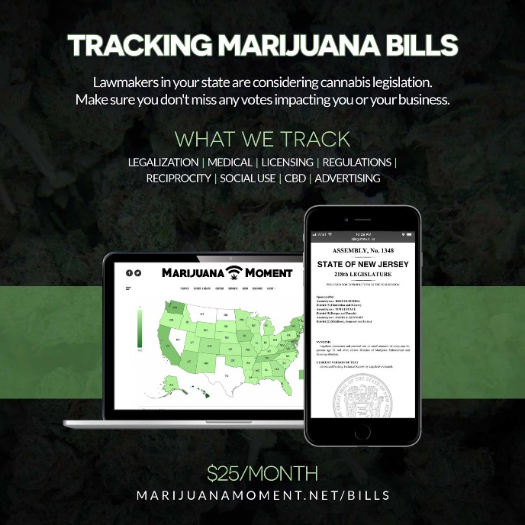
Learn more about our marijuana bill tracker and become a supporter on Patreon to get access.
—
Meanwhile, the House Rules Committee last month rejected multiple marijuana-related amendments to a series of spending bills, including proposals to ban certain federal agencies from testing job applicants for cannabis and prevent border patrol agents from seizing marijuana from state-licensed businesses.
The Appropriations Committee separately passed another spending bill last month that was amended to remove provisions safeguarding banks that work with state-licensed cannabis businesses. Members also reattached a section blocking Washington, D.C. from legalizing marijuana sales that was omitted from the base bill.
Photo courtesy of Mike Latimer.
Marijuana Moment is made possible with support from readers. If you rely on our cannabis advocacy journalism to stay informed, please consider a monthly Patreon pledge.

RELATED TOPICS:FEATURED

DON'T MISS
Massachusetts Marijuana Regulators Propose Leadership Changes Amid Ongoing Tensions


Kyle Jaeger

